# Conflict Scenario

## **Review**

### Interpersonal Conflict Management Styles

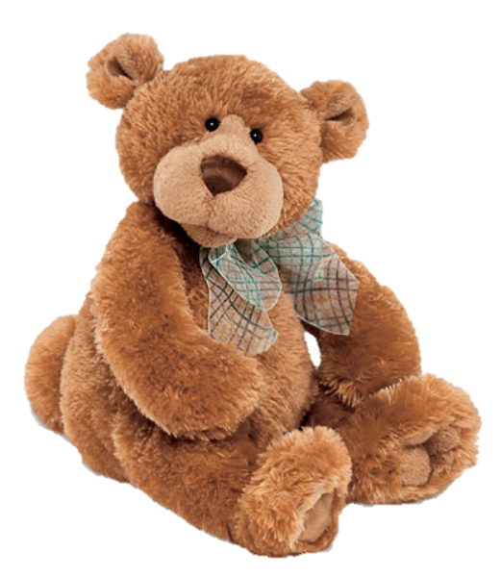

[CC 2.0 BY Matthew](https://www.flickr.com/photos/falcon1961/3304306800/)



[CC SA 3.0 Unported BY Jonathan Zander](https://en.wikipedia.org/wiki/File:Florida_Box_Turtle_Digon3.jpg)



[CC 3.0 BY Superawesomevectors](https://superawesomevectors.deviantart.com/art/Shark-Cartoon-Free-Vector-Illustration-643399222)



[CC0](https://pixabay.com/en/urban-lost-hiding-afraid-1002149/)

Low to High Concern for Other

Concern for Self



CC SA 2.0 Generic BY [Carine06 from UK](https://commons.wikimedia.org/wiki/File:Flickr_-_Carine06_-_%22I_give_up.%22.jpg)



CC 2.0 BY [Zabara Alexander](https://www.flickr.com/photos/zabara_tango/6955720271)



[CC0](https://commons.wikimedia.org/wiki/File:US_Army_53525_Soldiers_compete_in_Tae_Kwon_Do_tournament_for_Warrior_Country_level.jpg)

### **Interpersonal Conflict Resolution**

The following diagram shows a process that can be followed when trying to resolve interpersonal conflict.

### Listening

A considerable proportion of our communication involves listening, yet little attention is devoted to improving listening. HURIER is an acronym for tips that can be used to improve listening.

### “I” Phrases for Conflict Resolution

The “I” phrase is used during conflict resolutions to avoid attacking others. Open the conversation with a statement in first person, passive voice: “I feel … when … because … I would like …”

Adapted from (Dwyer 2012, p. 40)

## **Student Name and ID:** Cornel Van Der Westhuizen, 12123814

## **Student Name and ID:** Levi Munro, 12187881

## **Scenario**

Find a partner. Read the scenario below. Choose one partner to be Joe Bloggs, and the other to be Jane Doe. Together, answer the following to help prepare you for the role play.

## **Scenario: Joe did not complete a task by the deadline**

Joe and Jane are working on a report that is due today. Joe was assigned the task of writing the executive summary. Unfortunately, Joe has not completed the task.

What is the most appropriate conflict management strategy for Jane to use in this situation? (Choose one)

Compete/Force

Compromise

Avoid/Withdraw

Collaborate/Confront

Accommodate/Smooth

Why did you choose the above conflict management strategy?

They must collaborate instead of Jane forcing Joe to do the work, otherwise he may still not want to complete the work out of spite. It is not Janes task to complete, so completing it herself should not be an option

### **Listen and Understand**

How could Jane start the conversation?

Remind Joe of the task that needs to be completed in a no-confronting, passive manner

Describe the purpose of the discussion. Describe the conflict. What questions could Jane ask to determine Joe’s perspective of the situation?

Purpose: Attempting to get Joe to do his part of the task. Conflict: Joe he might not want to complete the task or even collaborate with Jane to complete it. If this is the case, Jane would need to report the situation to Joe’s manager. Questions Jane could ask Joe:

Why have you not completed the task?

Do you need help completing the task?

Write sentences that features the “I” phrase, such as in the example below:

“I feel *[your feeling]* when *[their behaviour]* because *[effects on you]*. I would like *[alternative behaviour]*”.

I feel disappointed when you do not complete your task on time because then I need take time out of my own schedule in order to assist you. I would like you to try managing your time more efficiently.

Other alternate behaviours:

Asking for a time extension

Seeking help from peers before deadline

Invent a reason why Joe did not complete the executive summary by the deadline.

A loved one passed away, and Joe did not feel like letting anyone know

How could Jane paraphrase Joe’s reason for missing the deadline to ensure that she understands Joe’s perspective?

“So the way I understand it, the passing of someone you knew was too close to your heart and you preferred not to tell anyone immediately?”

### **Empathise**

Now that Jane understands Joe’s perspective, how could Jane empathise with Joe? Write a response that shows that Jane identifies with Joe’s emotions.

“I can’t say I know how you feel, but just so you know I will be here for you if you need anything”

### **Apologise**

Include an apology if it is appropriate.

Click or tap here to enter text.

### **Offer Solution**

What question could Jane ask to help build Joe’s involvement with potential solutions?

“Have you tried talking to your manager to see if you can get any sort of time extensions?”

Come up with a way for Jane and Joe to settle on a solution.

Joe discusses with Jane and asks her if she is able to complete part of the task, in order to increase the speed of task completion, or if an extension is required from his manager

### **Resolution**

How could Jane resolve the conflict? Jane needs to ensure that Joe agrees. Write a response that outlines appreciation for the solution.

Jane accepts Joe’s offer to help with part of the task. Joe agreed that it is a suitable solution.

### **Reconciliation**

How could Joe reconcile the relationship and let Jane know that she is important to him?

Joe: “I really appreciate your help. Do you want go watch a movie?”

How can Jane let Joe know she is listening while Joe is talking?

Give no-verbal cues (eg. Head nodding) to Joe while he is talking

Jane responds with “That’s no problem. I am happy to help if something like that comes up again.”

What could Jane do if Joe started to withdraw from the conflict at any stage?

Jane: “Can we meet in an hour?”